

Admin Guide for Batik Explorer App

Written to fulfill the 1st task of

**Web Programming for Mobile Devices**

Group : 10

Names : Ahmad Zainul Mufid (2220010002)

Rizq Rahid Khairullah (2220010046)

Class : 4 SE 2

CEP CCIT

FAKULTAS TEKNIK UNIVERSITAS INDONESIA

2024

**PROJECT ON**

*Admin Guide for Batik Explorer App*

**Developed by**

1. **Ahmad Zainul Mufid**
2. **Rizq Rahid Khairullah**



**Admin Guide for Game App**

Batch Code : 4SE2

Start Date : Wednesday, April 24th, 2024  
End Date : Tuesday, May 7th, 2024

Name of Faculty : Mrs. Indah Ayu Yuliani, S.T., M.M.

Names of Developer :

1. Ahmad Zainul Mufid
2. Rizq Rahid Khairullah

Date of Submission: Wednesday, May 8th, 2024



**CERTIFICATE**

This is to certify that this report titled “Admin Guide for Batik Explorer App” embodies the original work done by Ahmad Zainul Mufid, and Rizq Rahid Khairullah. Project in partial fulfillment of their course requirement at NIIT.

Coordinator:

Mrs. Indah Ayu Yuliani, S.T., M.M.

First of all, Praise be to God for His grace and guidance, authors can compose and present a paper that contains about Implementation of Information Technology in an apartment, as one of IT Introductory lecture. The authors also thanked to Mrs. Indah Ayu Yuliani, S.T., M.M. as lecturer Introductory IT course that have provided guidance to the authors in the process of preparing this paper. Not to forget the authors thank the various parties who have given encouragement and motivation

The author realizes that the preparation of this project there are still many shortcomings and far from being perfect. Therefore, the authors expect constructive criticism and suggestion to improve this paper and can be reference in preparing the papers or subsequent tasks.

The authors also apologize if in writing this paper there are typos and errors that confuse the reader in understanding the author’s intent.

Depok, April 24th, 2024

**ACKNOWLEDGEMENT**

**Background**:

This project was created as an assignment for assessment in the Web Programming for Mobile Devices module. In this project, the author chose the topic "Admin guide for batik explorer". The author chose this topic because it is interesting to create and design. In addition, this web is made for the next project, so the author wants to improve its appearance.

**Overview App**:

Admin guide for batik explorer is an application to enter information about incoming batik and will later be recorded in the application. This application was created for admins to facilitate the entry of batik and record incoming batik. this website also explains about batik in general before the process of entering as an admin. admin here plays a role in entering batik information data which will later be marketed again.

**Technology**:

The technology that the author uses to design wireframes is Figma and which will be implemented into the web for Admin using HTML, CSS, JavaScript along with firebase.

**SYSTEM ANALYSIS**

**ACTIVITY LIST**

|  |  |  |  |  |  |
| --- | --- | --- | --- | --- | --- |
| **No.** | **Activity Description** | **Planning Date** | **Actual Date** | **Respons** | **Remarks** |
| 1. | Create the wireframe design using figma | 24 April 2024 | 25 April 2024 | Zainul | 3 wireframe design (Desktop, Mobile) |
| 2. | Create Landing Page using HTML, CSS, and Javascript | 25 April 2024 | 06 May 2024 | Rizq | Navbar, Banner, Content, and Footer |
| 3. | Create Login & Register Page using HTML, CSS, and JavaScript with firebase | 29 April 2024 | 01 May 2024 | Zainul | One page Login & Register |
| 4. | Create Loader Page using HTML, CSS, and JavaScript | 25 April 2024 | 28 April 2024 | Rizq | Animation Loader |
| 5. | Create Dashboard page using HTML, CSS, and Javascript with Firebase | 02 May 2024 | 04 May 2024 | Zainul | Navbar and Banner |
| 6. | Create Data Edit Page using HTML, CSS, JavaScript with Firebase | 02 May 2024 | 06 May 2024 | Zainul | CRUD data |
| 7. | Create Table View using HTML, CSS, and Javascript with Firebase | 02 May 2024 | 06 May 2024 | Zainul | Table View |
| 8. | Create responsive web for desktop, tablet, and mobile | 25 April 2024 | 06 May 2024 | Zainul & Rizq | Success |

CRUD page

Dashboard page

Register page

Login page

Loader page

Landing page

**Desktop Display**

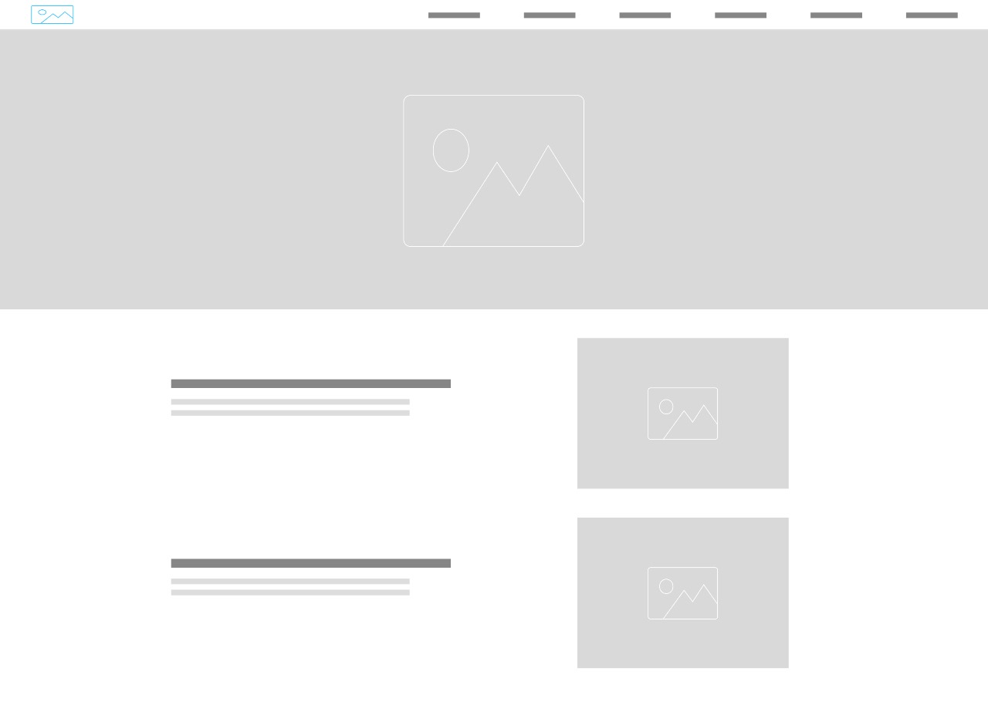 

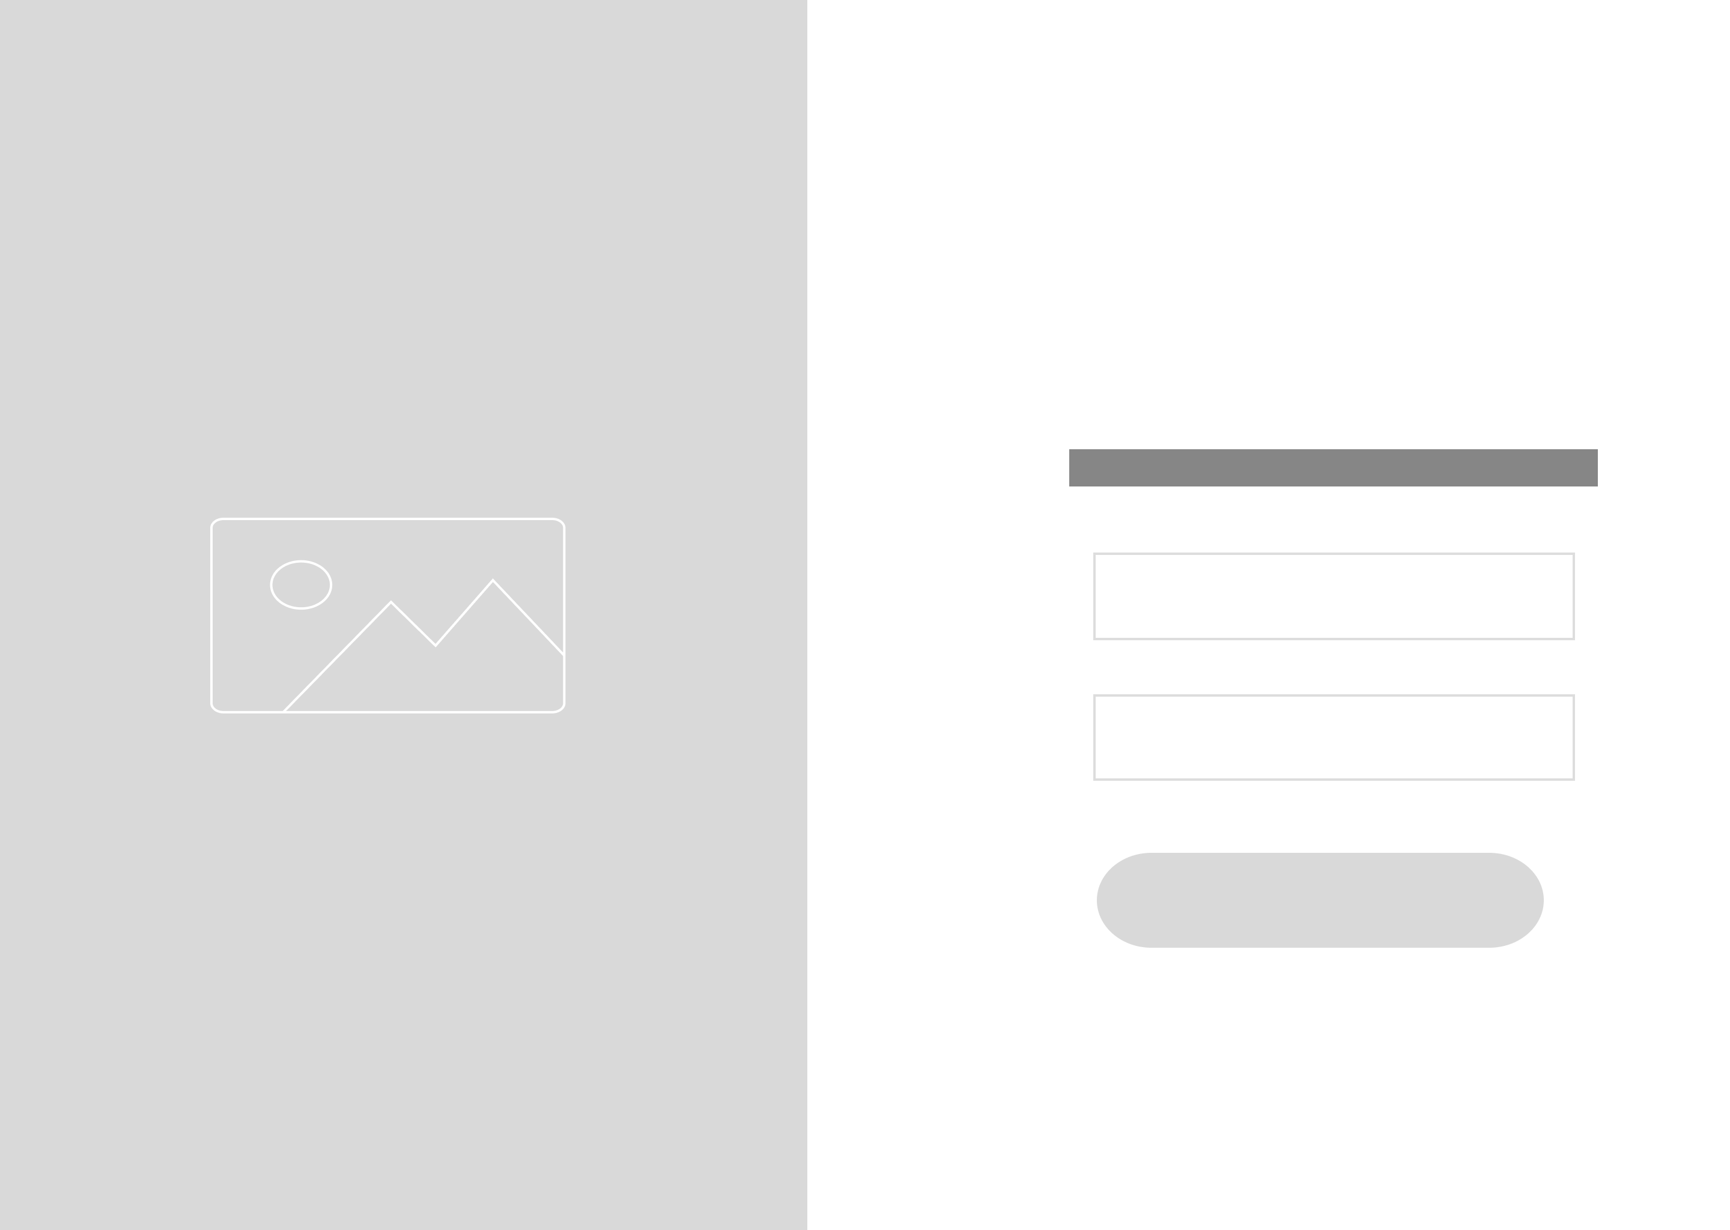 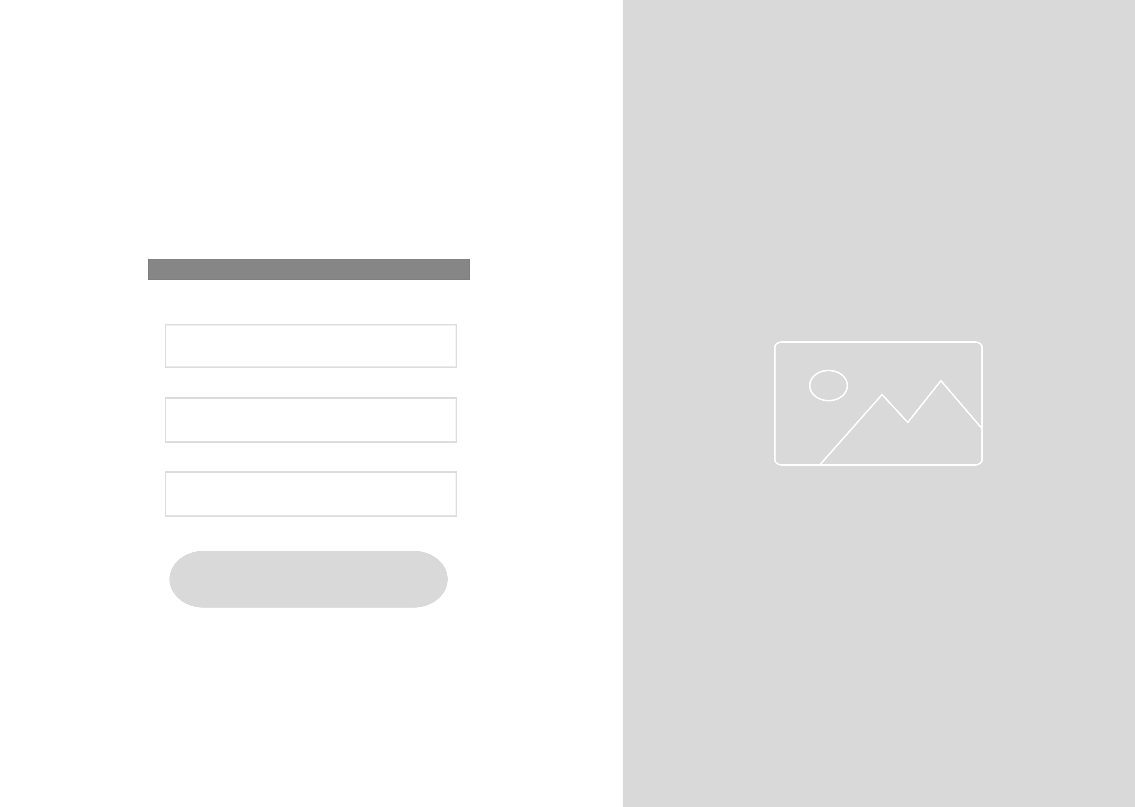

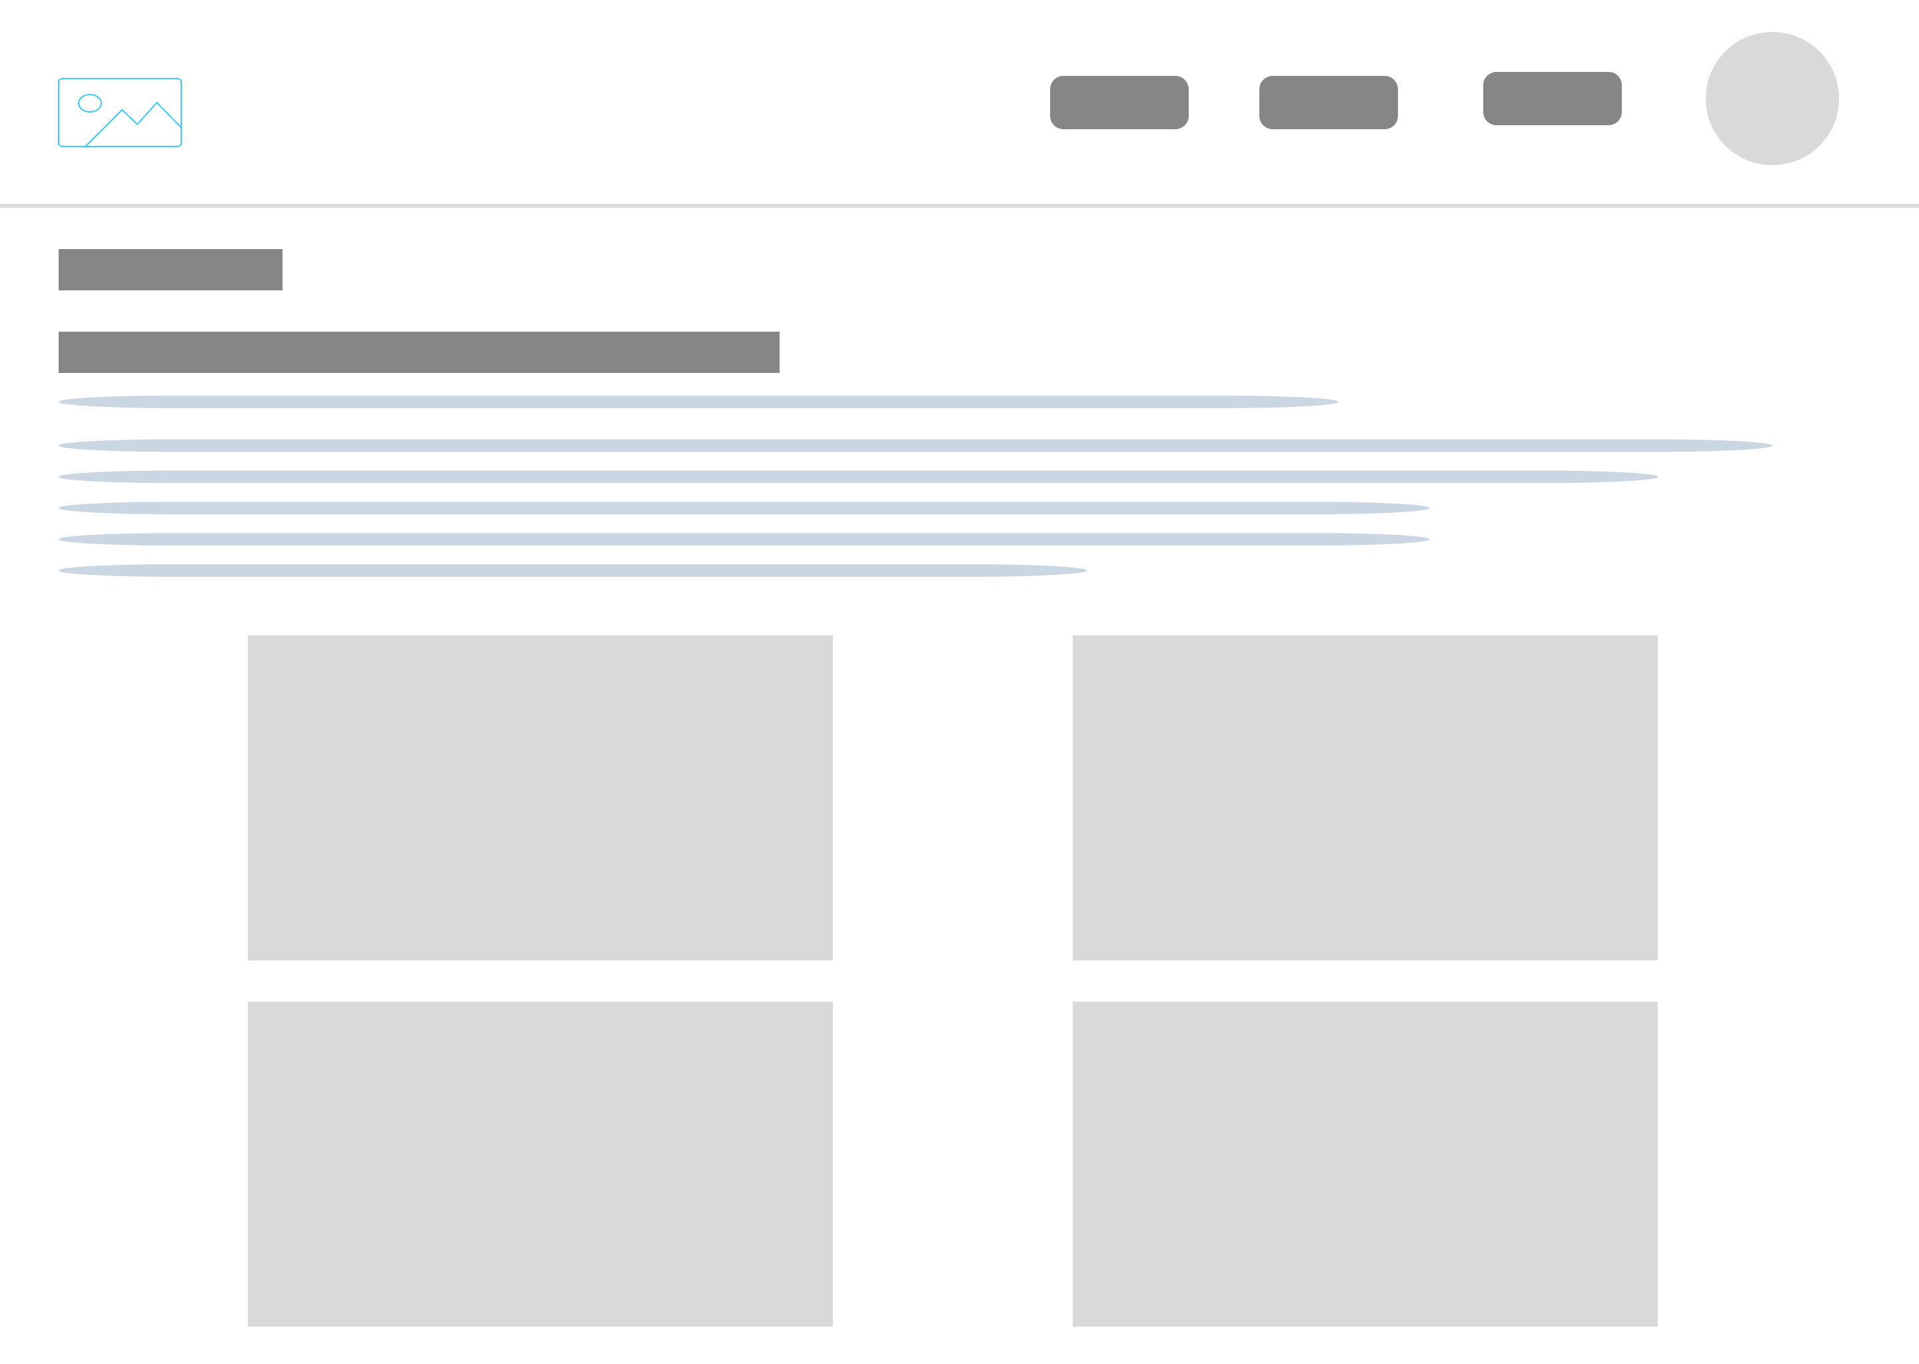 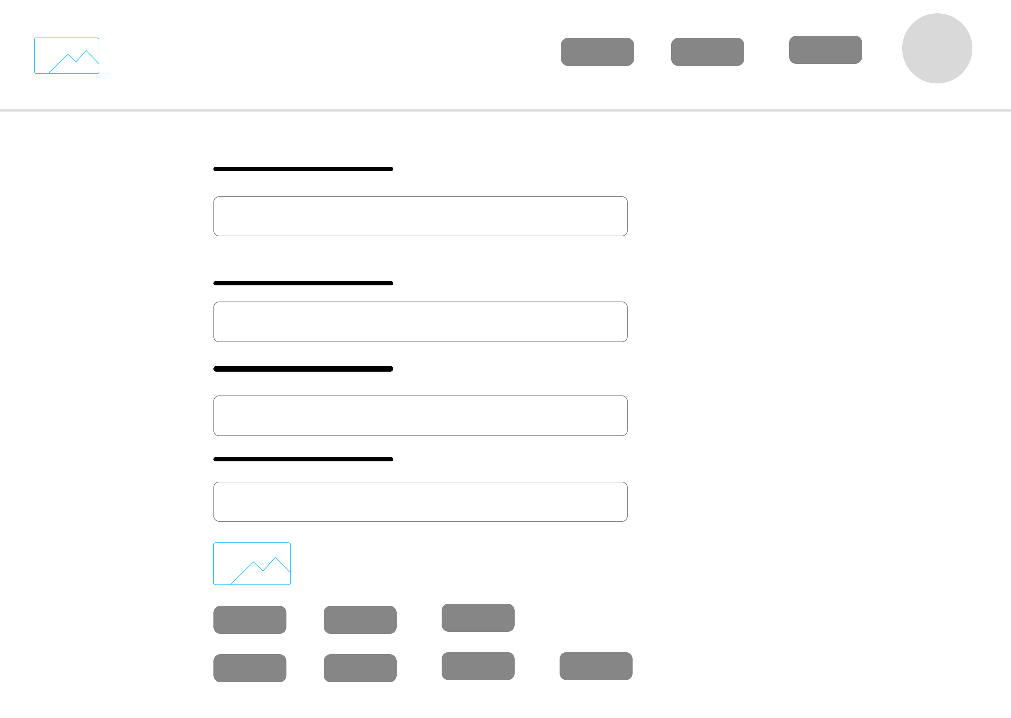

**WIREFRAME DESIGN**

Table View page

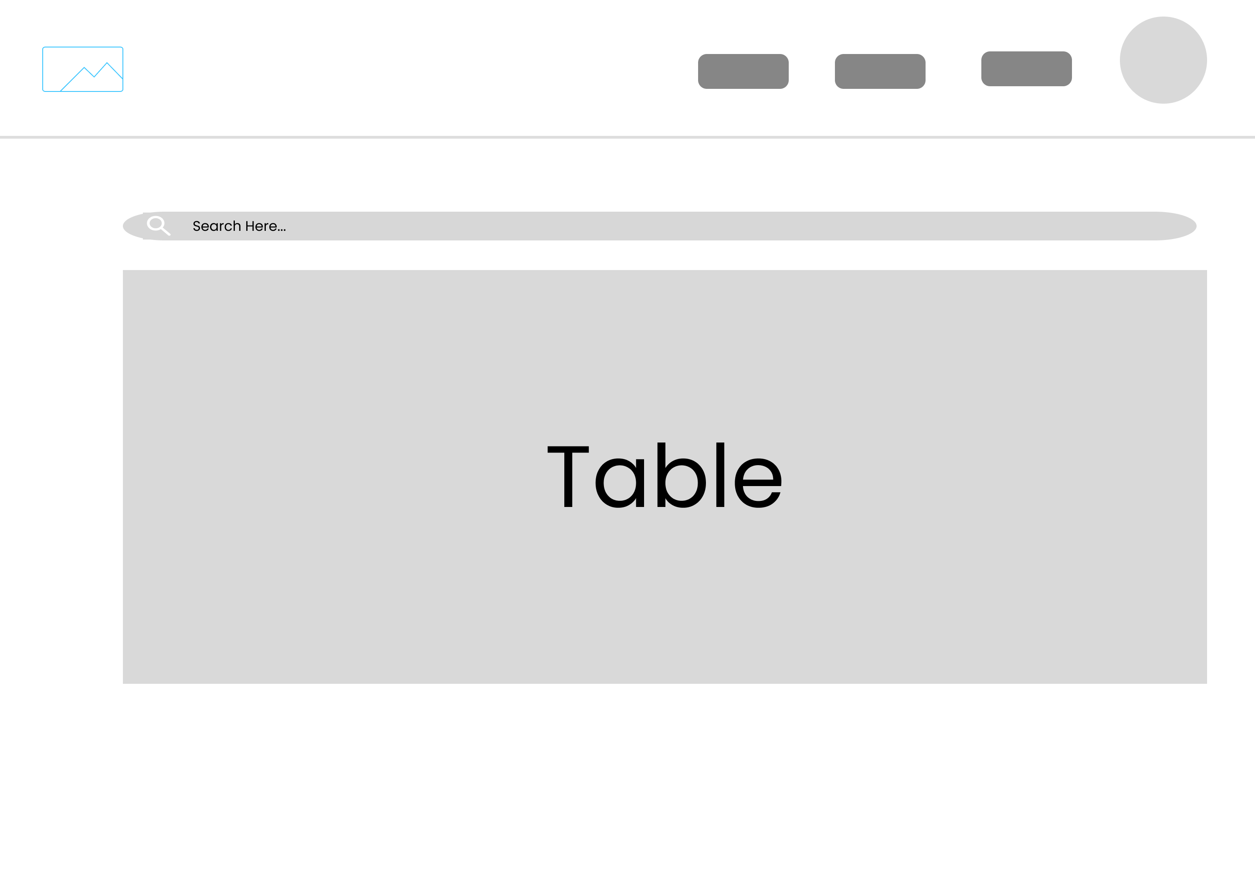

**WIREFRAME DESIGN**

**WIREFRAME DESIGN**

**Mobile Display**

   

 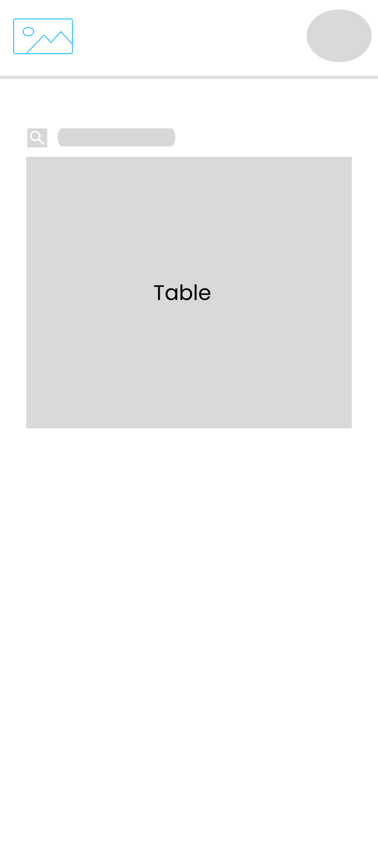 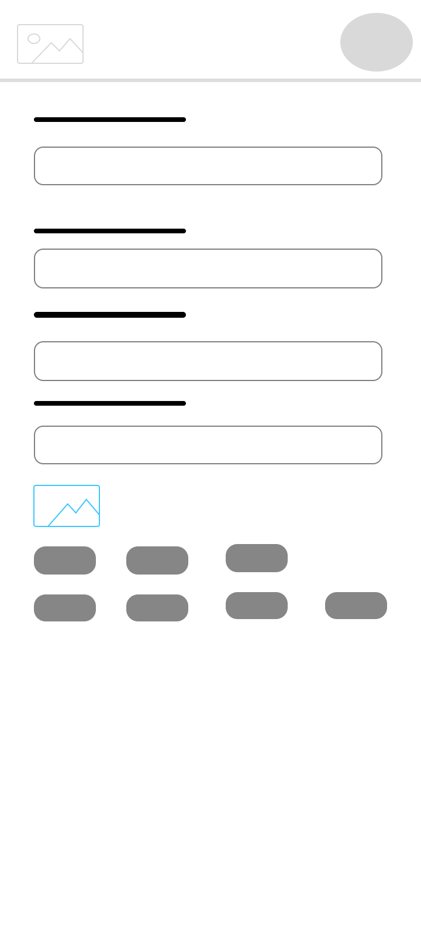

  

Register page

Login page

Loader page

Landing page

**IMPLEMENTATION**

|  |  |  |
| --- | --- | --- |
| **Use** | **On** | **Utilization** |
| HTML5 | landing.html, loader.html, login.html, register.html, index.html, bismillah.html, and bismillahbisa.html | As a web page structure framework |
| CSS | bisa.css, loader.css, style.css and landing.css | As a custom CSS using media Queries to set the responsiveness and make the interface more attractive |
| JavaScript & Firebase | Login, Register, CRUD | To perform admin validation |
| Navbar, loader, banner, data table, data edit | For dropdown menu, CRUD data |

1. This page is to introduce about batik
2. Loader Page in to redirect login or register

**PREVIEW OF WEB**

**Dekstop Display**

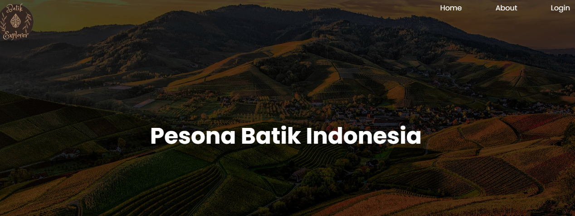



1. Register page, to register an account for a new admin
2. Login page, to enter the website using the admin account

**PREVIEW OF WEB**

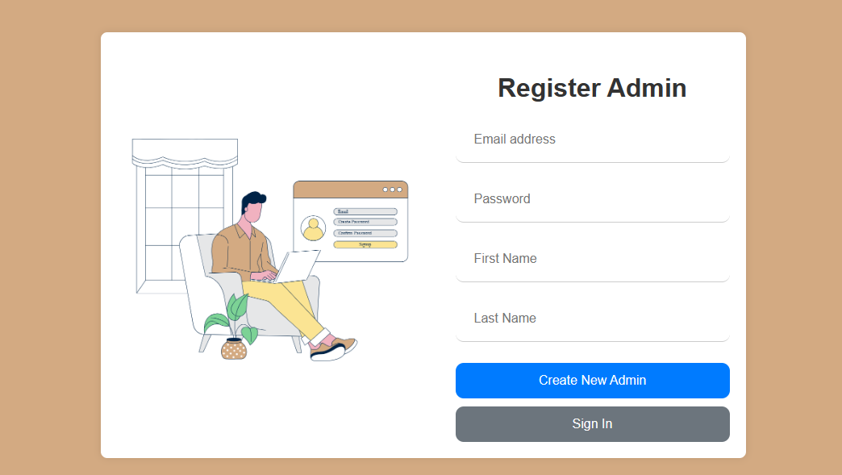

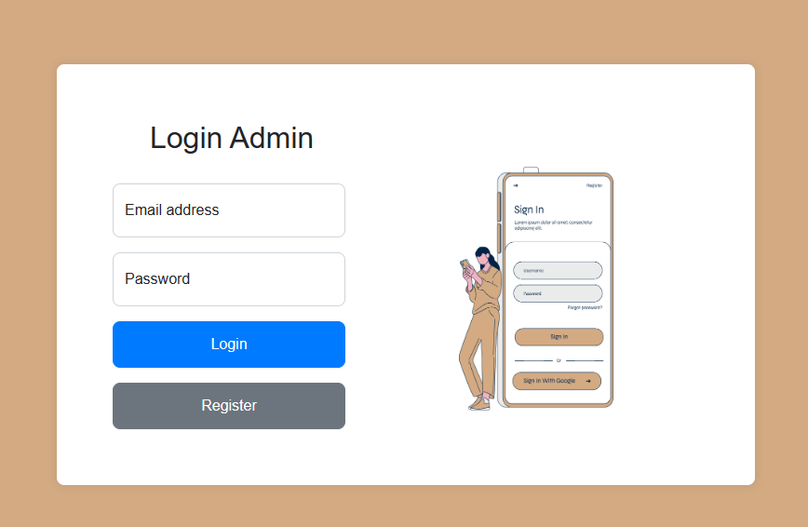

1. CRUD Page, Here you can add images, information about batik, and data can be updated or retrieved from firebase.

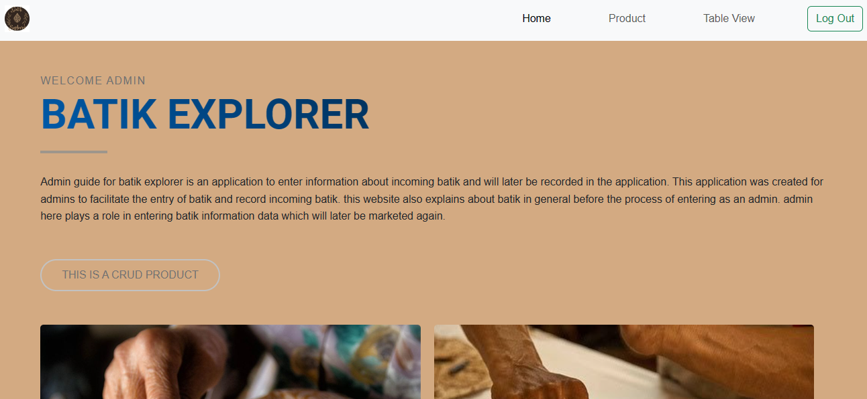

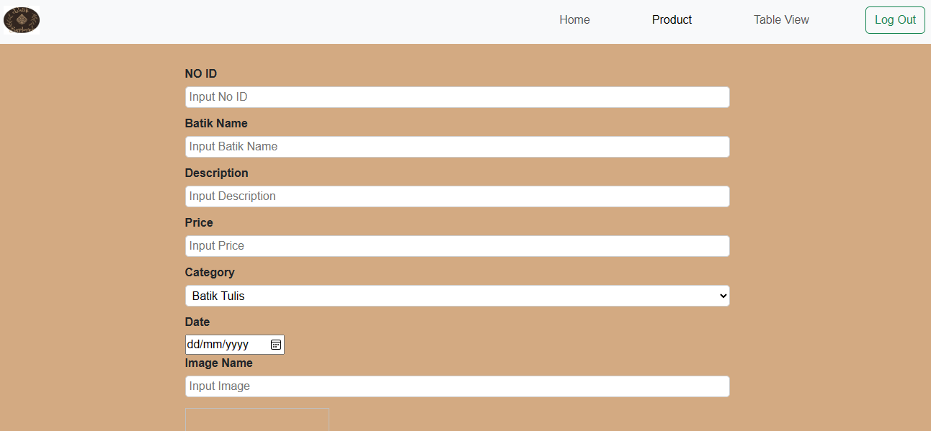

1. Dashboard page, Here you can see a brief explanation of the batik explorer app. here there are also several kinds of buttons with their respective functions such as the navbar product for crud and table view that is the result of crud in the form of a table.

**PREVIEW OF WEB**

1. Table View Page, Here displays information that has been crud and entered into firebase and will later be displayed in the view table and search by batik name to make it easier for admins to search.

**PREVIEW OF WEB**

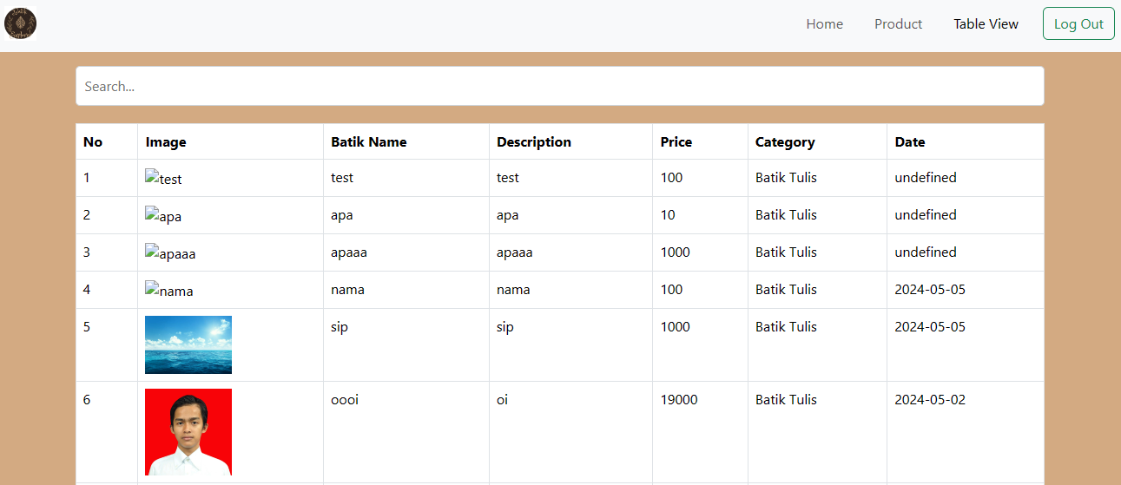

**PREVIEW OF WEB**

**Mobile Display**

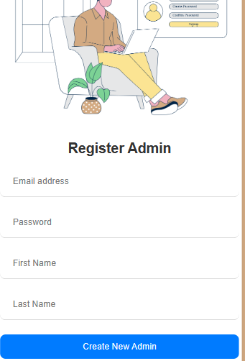

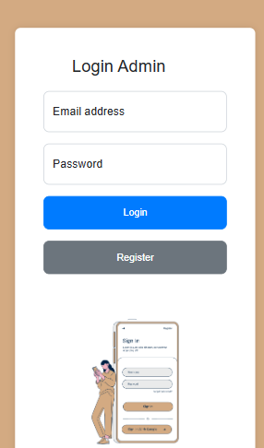 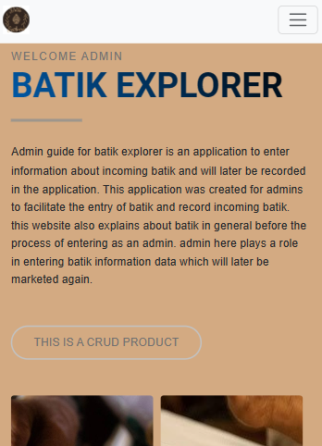 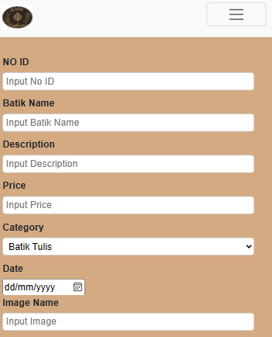

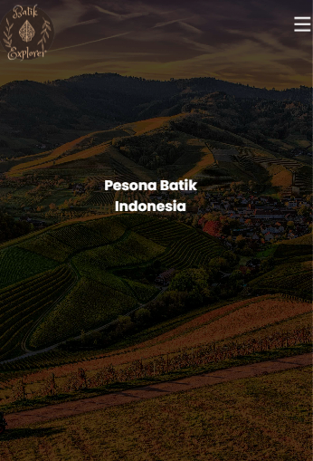

**PREVIEW OF WEB**

**Mobile Display**

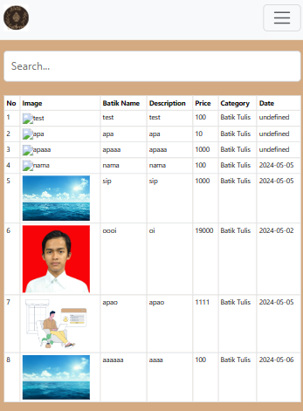

**Hardware :** Laptop Asus TUF 15, Lenovo Ideapad 131Kb

**Operating System :** Windows 11 Home Single Language 64-Bit

**Software :** Figma, Visual Studio Code, Browser

|  |  |  |
| --- | --- | --- |
| **PROJECT FILE DETAILS** | | |
| **S.No** | **File Name** | **Remarks** |
| 1 | Admin_Guide for Batik Explorer App_Group 10_4SE2.docx | Paper |
| 2 | Admin_Guide for Batik Explorer App_Group 10_4SE2.pptx | Slideshow |
| 3 | Admin_Guide for Batik Explorer App_Group 10_4SE2.zip | Visual Studio Code and Figma |

**CONFIGURATION**